1. Image of the circuit

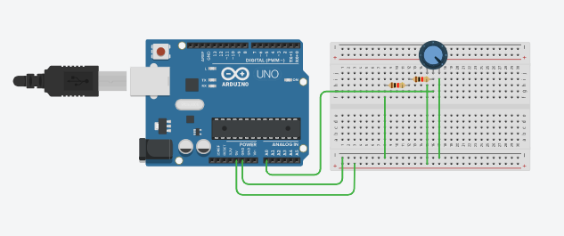

1. Image of code

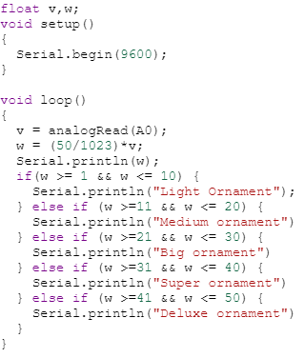

1. [Tinkercad](https://www.tinkercad.com/things/0akzSnTKcUs-fantabulous-sango-bigery/editel?sharecode=QdgL2jKm4VFICam4TgRMUgzCNPtyLnXsuaLRsDWXNsk)
2. **AU1940049 Sameep Vani**